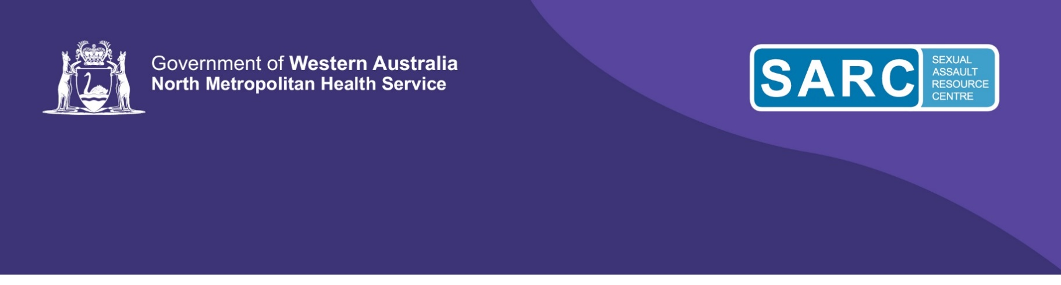
Full Day Workshop Registration

Trauma Counselling Skills
Friday 10th November 2023
Workshop details
Date: | 10th November 2023
Time: | 9:00 am – 4:30 pm (8:45 arrival for a prompt start)
Cost: | $132 incl GST
Venue: | Subiaco location. Details will be provided to registered participants approximately 10 days prior to the workshop.
Catering: | Lunch and refreshments provided. SARC uses external caterers and cannot guarantee safety for food allergies. Vegetarian options can be requested. If you have food allergies, we recommend self-catering.

Participant details
Name:
Employer:
Job Role / Occupation:
Address:
Email: |  | Phone No:
Emergency Contact Name: |  | Phone No:
Special learning requirements:
Special access or mobility requirements:
Vegetarian catering requested (Y/N):
Payment details

Amount: $132

Cheque/money order made out to: SARC Education and Training
 | Post your completed forms and payment to Education & Training, SARC, PO Box 842, Subiaco, WA 6904
 | Credit Card (complete section below).
 | VISA |  |  | MasterCard
 | Name on Card |  | Card Number: |  | Expiry Date: /
Registration: |  | Please return completed registration forms to SARCTraining@health.wa.gov.au

